Insight Log Analysis Tool:

Introduction:

The insight log analysis tool is intended to provide general statistics on use of the Luna Insight Software. It is intended to provide information to collection managers and system administrators on who accesses that collection, what they search for, how many results are found, what images they look at, and what images they download for a given collection.

Installation:

Files Included:
Logs/ -- contains sample logs
Sample_Output/ -- contains sample output
Perl/ -- contains the analyzer script and all required files
Sample_commands/ -- contains sample commands for running daily,
weekly, monthly, and annual log reports

Where to install the log analyzer:

In general it will probably make sense to install the log analyzer on the same machine that your collection manager is installed. Note, log analysis is a processor intensive application and should be scheduled at off-peak times.
When choosing where to install and run the log analyzer, be aware that it requires access to the following log files:
- the collection’s web server logs (to determine which images were viewed)
- the collection’s access, query, and export logs (to determine who logged in, searches run, and images exported) These are generally located in the same folder as your collection server
- the browser’s access and query logs (to determine who logged in and searches run) These are generally located in the JSP Browser’s logs folder.

Installation:
- Replace the new JVA and the JSP Browser jar & JSP files with the ones packaged. (for Insight 3.5 users only).
Note: the following changes to the BrowserInsight.conf are necessary to enable logging support:
  - The following lines need to be added to the file:
SessionLogFile = Browser-Insight-Session-Log.txt
SessionLogMode = 1
  - The Search Query log should just be the filename (not including the full path to the file) eg:
SearchQueryLogFile = Browser-Insight-Query-Log.txt

- Install perl 5.6.1 or higher on your machine (if it is not already installed).
- Unzip and copy the log analyzer files on to your server
- Install the following perl modules. You can download the latest versions of these modules off of CPAN (http://search.cpan.org). If you are on windows and are using the Active State distribution of perl, you can load the Perl Package Manager (PPM) by typing PPM in a dos prompt and then typing install <Module Name>. The required modules include:
  - Time::ParseDate
  - Archive::Zip
  - Net::IP
  - CGI (generally included with all perl distributions)
- Edit first line of the analyzer.pl file (in the perl folder) to point to the perl executable
#!c:\perl\bin\perl.exe --> #!/path/to/excecutable

Sample output:
Sample log data and sample log files are included in the installation package in the logs directory and sample_output directory. Finally, sample invocations of the log analyzer for common reports are stored in the sample_commands folder. See Figure 1 for a screenshot of a sample report.

Figure 1: Screenshot of a sample report (other samples are available in the sample_output folder
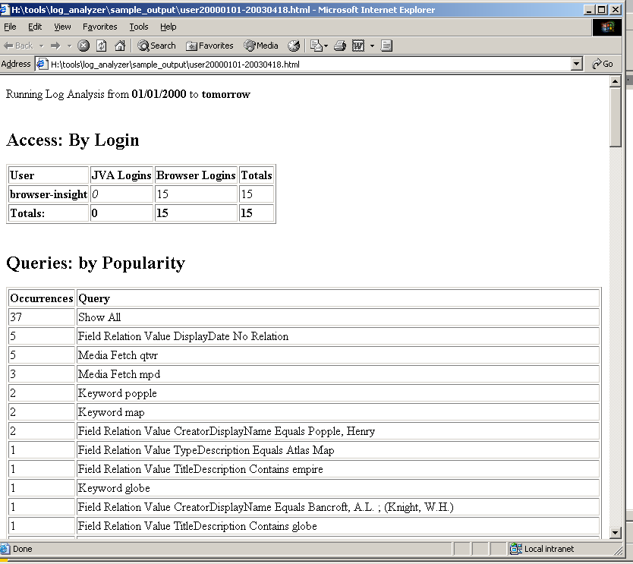

Configuration and Use:

Valid Log Files:
As some changes were necessary to make log files parse-able, only log files created from a v3.50.4 server will be properly parsed. As changes to the client are necessary to record the individual username in the access log, this type of logging will require a 4.0 client.

Apache, IIS, and Media Security Server Log files:

IIS Log Files:
For IIS log files to be processed, they must have the following values in the W3C format. Date, Time, Client IP, Method, URI Stem, URI Query, Status

Apache Log Files:
For Apache log files to be processed, they must be in either common or combined format.

Media Security Server Log Files:
These will work in their current format.

Required Log files:
The following log files are needed to properly produce a report:
- IIS (W3C format see above) or APACHE (common) Web server log
- Insight JVA Access log
- Insight JVA Query Log
- Insight JVA Export Log
- Insight Browser Access Log (Optional). Note: as the browser can support multiple collections one log file is created per collection and has the appropriate Collection ID appended to the beginning of the file (in order to easily determine which is the correct log file)
- Insight Browser Query Log (Optional) Note: as the browser can support multiple collections one log file is created per collection and has the appropriate Collection ID appended to the beginning of the file (in order to easily determine which is the correct log file)

invocation:

perl analyzer.pl usertype=inst process=all headerfile=headerfile.html ...

passing parameters to analyzer.pl:

command line properties can be passed to analyzer.pl either via the command line or via a properties file specified on the command line. The properties file is a simple way to pass the same set of properties over multiple invocations (good for IP mapping).

Note on log directories:
The log directories passed to the log analyzer must contain the JVA and Browser log files for ONE COLLECTION ONLY, with the exception of the web server log. This is to ensure that log data from multiple collections are not combined.

Usertypes:
Insight supports two different concepts of a users: Individual users and Institutional users. Individual users are defined by usernames in the user manager while institutional users are defined by a group name (the one paired with a code-key). The log analyzer by default will assume that it should treat users as institutional users, however this can be overridden by the usertype parameter.
Note: recording access of individual users by username requires a 4.0 client.
Figure 2: Configuration parameters for the Log Analyzer
Parameter |  | Example |  | Repeat? |  | definition | Required
logdir |  | logdir=c:\logs |  | Y |  | Specifies one or many log directories where logfiles may be found for processing | YES
fromdate |  | fromdate=01/01/2000 or fromdate=last year or fromdate=last month or fromdate=last week or fromdate=yesterday |  | N |  | Specifies the first valid day for a log entry | YES
todate |  | todate=01/01/2000 or todate=last year or todate=last month or todate=last week or todate=today or todate=tomorrow |  | N |  | Specifies the last valid day for a log entry | YES
outdir |  | outdir=c:\inetpub\... |  | N |  | Specifies the output directory for reports | YES
cid |  | cid=1 |  | N |  | Specifies the collection id for the collection to report on | YES
iid |  | iid=LUNA |  | N |  | Specifies the institution id | YES
vcid |  | vcid=NA |  | N |  | Specifies the virtual collection id (NA if this is not a virtual collection) | YES
propsfile |  | propsfile=analyzer.dat |  | N |  | Specifies the filename of the properties file (see figure 3 for an example) | NO
usertype |  | usertype=Institution or usertype=User |  | N |  | Specifies whether users are grouped by their groupname or by their username | NO
process |  | process=all or process=username |  | N |  | Specifies the user(s) to process. All specifies process all user, specifying a user limits processing to just that user | NO
headerfile |  | headerfile=header.html |  | N |  | Prepends the headerfile to the beginning of the log report (good for adding an image or title) | NO
footerfile |  | footerfile=footer.html |  | N |  | Appends the footerfile to the end of the log report | NO
fileprefix |  | fileprefix=luna |  | N |  | Specifies the prefix for a filename, i.e. if rumsey is specified, a filename might be rumsey2001-2004.html | NO
logsuffix |  | logsuffix=log |  | Y |  | Specifies one or many allowable suffixes for a logfile (so the script will not try and parse invalid file types). Note: zip files are a valid format | NO
overideWebRegex |  | overideWebRegex=/luna/|client=luna |  | N |  | Allows an administrator to filter down the HTTP log further using a Regular Expression, in example, URL contains /luna/ or client=luna | NO
mingroupfilter |  | mingroupfilter=10 |  | N |  | Specifies the minimum number of times a group is accessed before it is displayed in the group access log | NO
minresultfilter |  | minresultfilter=10 |  | N |  | Specifies the minimum number of results for a search before that search is displayed in the search results log | NO
minpopfilter |  | minpopfilter=10 |  | N |  | Specifies the minimum number of times a search is performed before it is displayed in the popularity log | NO
minaccessfilter |  | minaccessfilter=10 |  | N |  | Specifies the minimum times a user must login before they are displayed in the access log | NO
minexportinstfilter |  | minexportinstfilter=10 |  | N |  | Specifies the minimum number of times an institution exports images before it is displayed in the export log | NO
minexportfilefilter |  | minexportfilefilter=10 |  | N |  | Specifies the minimum number of times an image is exported before it is displayed in the export log | NO
minwebinstfilter |  | minwebinstfilter=10 |  | N |  | Specifies the minimum number of times an institution accesses images before it is displayed in the image access log | NO
minwebfilefilter |  | minwebfilefilter=10 |  | N |  | Specifies the minimum number of times an image is accessed before it is displayed in the image access log | NO
map |  | map=131.229.219.0-131.229.219.255: TEST |  | Y |  | Specifies an IP address or range of IP addresses to map to a given user or group. Valid IPs include:  A range: 20.34.101.207 - 201.3.9.99  An IP: 193.0.1.46 | NO

Figure 3: Sample properties file:
# note lines starting with a # are comments
logdir=H:\tools\log_analyzer\logs\
#logdir=C:/inetpub/wwwroot/log_analyzer/logs/
logsuffix=log,txt
logsuffix=zip
map=131.229.219.0-131.229.219.255: TEST

